Automated Resume Submission using n8n

Project Overview
This n8n automation project is designed to fully automate the job application process — from fetching new job listings to sending personalized emails with resumes and tracking submissions in real time. The workflow eliminates manual effort, ensures consistent follow-ups, and keeps a record of all applications sent.

Automated Resume Submission Using N8N
Summary Page

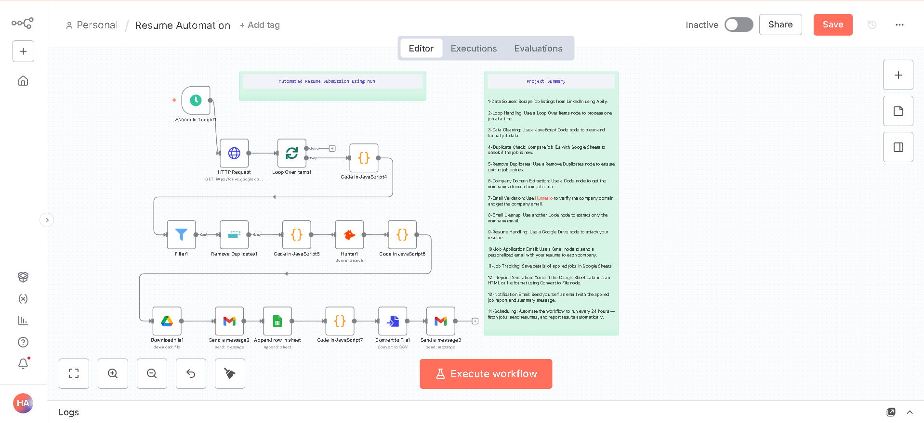

Job Fetching from Apify
This step automatically collects the latest job postings from online job platforms. Its purpose is to keep the system updated with fresh opportunities without any manual searching or input.

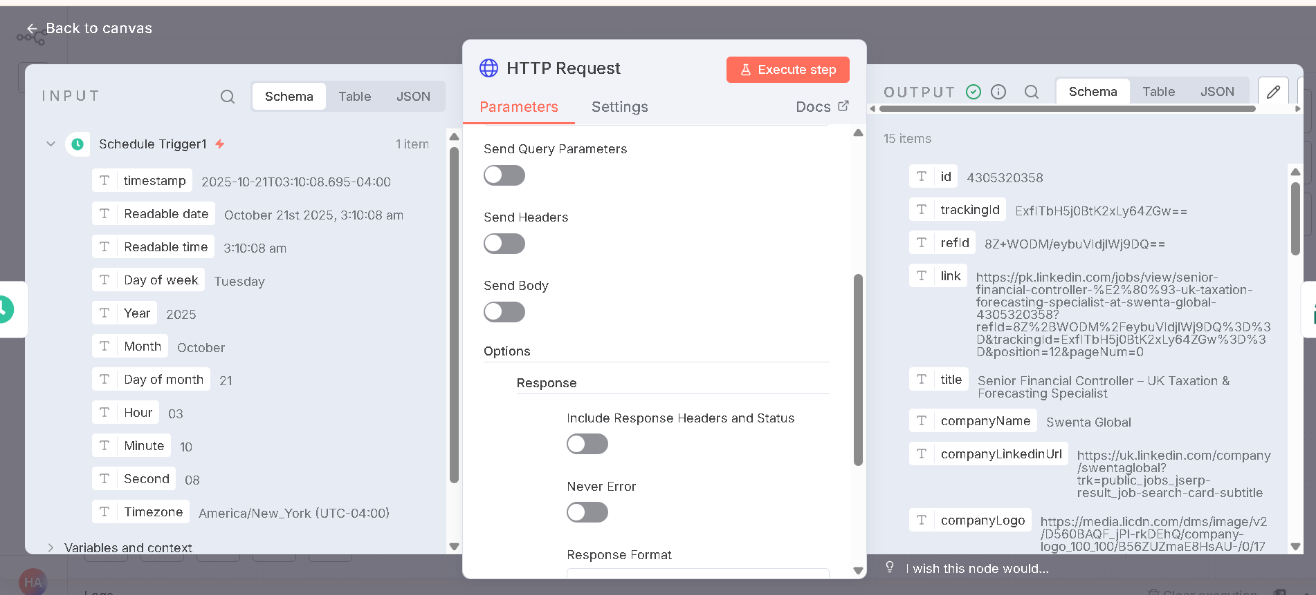

Email Retrieval via Hunter.io
This step finds the official contact email of each company. The purpose is to ensure that every job application is sent to the correct and verified company address, improving the chances of response.
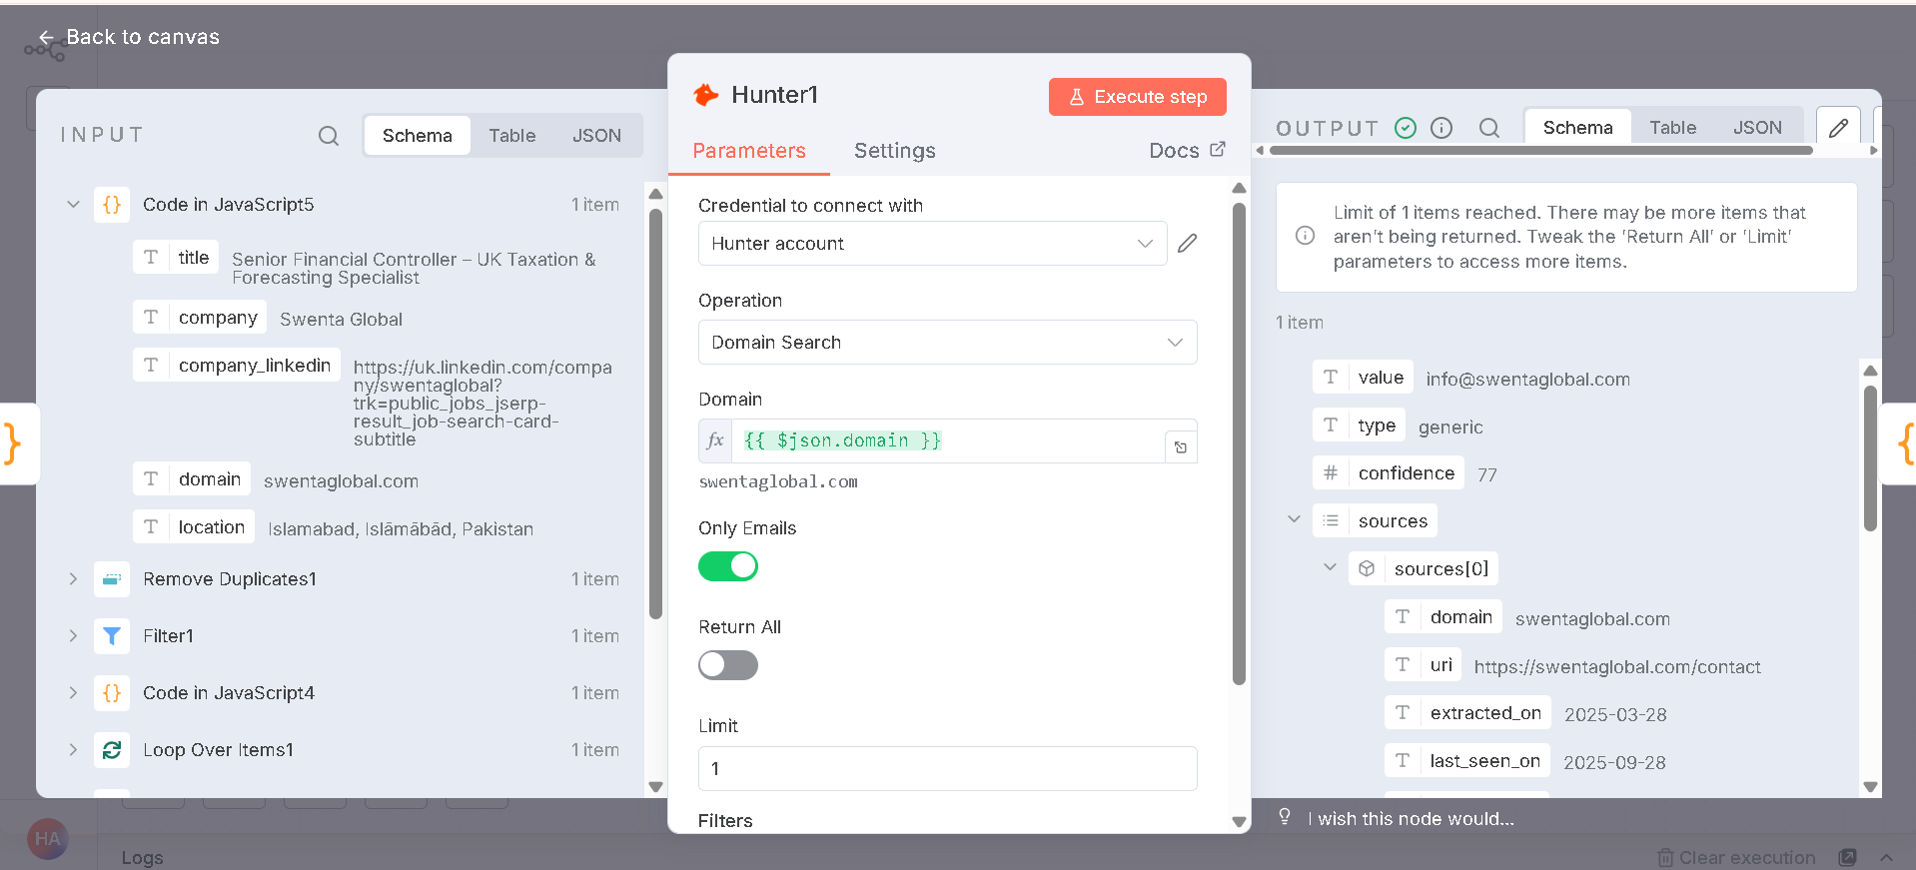

Resume Sending at Company Email
In this step, the system automatically sends a personalized email with the attached resume to the company’s email address. The purpose is to apply for each relevant job efficiently and professionally without manual effort.
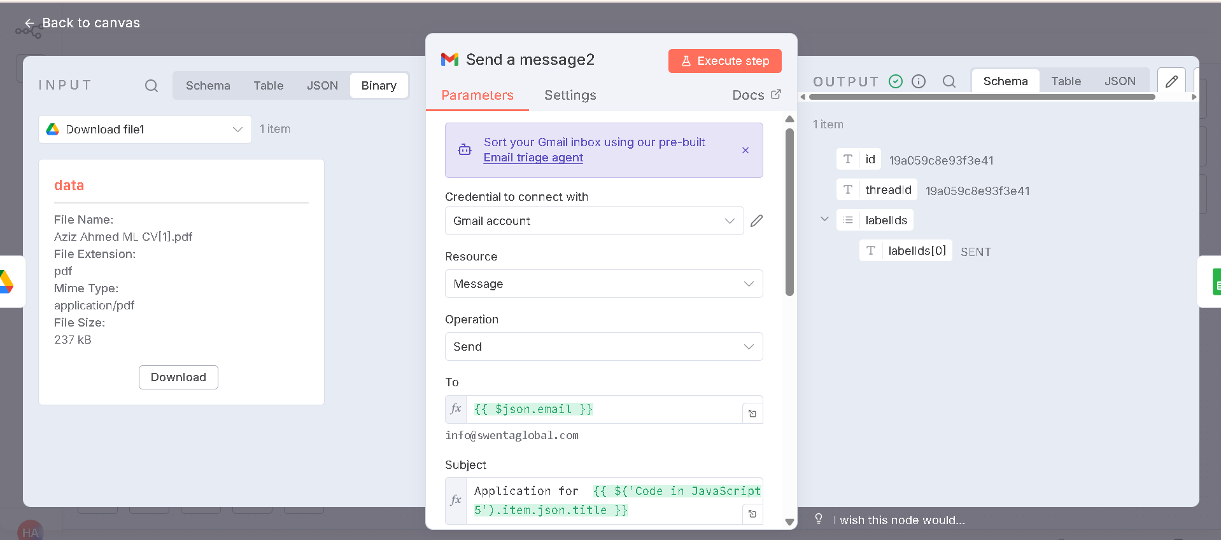

Job Data Logging
This step records all the details of jobs to which the resume has been sent, including company name, email, and status. The purpose is to maintain a clear and organized record of all applications for tracking and reference.
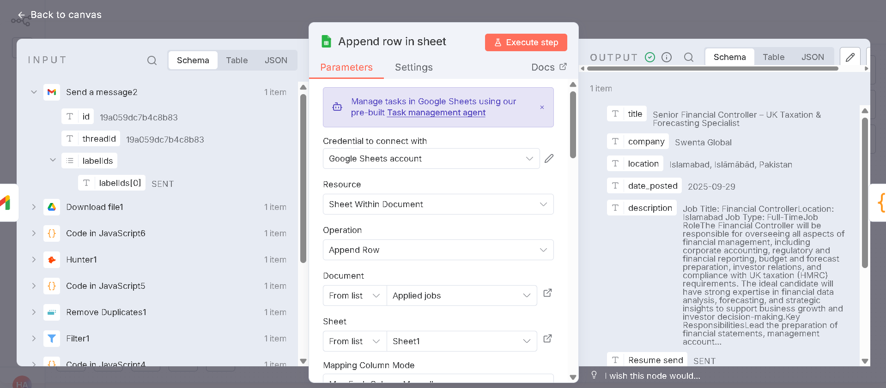

Report Generation & Notification to Client
This final step compiles all the application data into a summary report and sends it to the client. The purpose is to provide regular updates on all jobs applied to automatically, ensuring transparency and progress tracking.
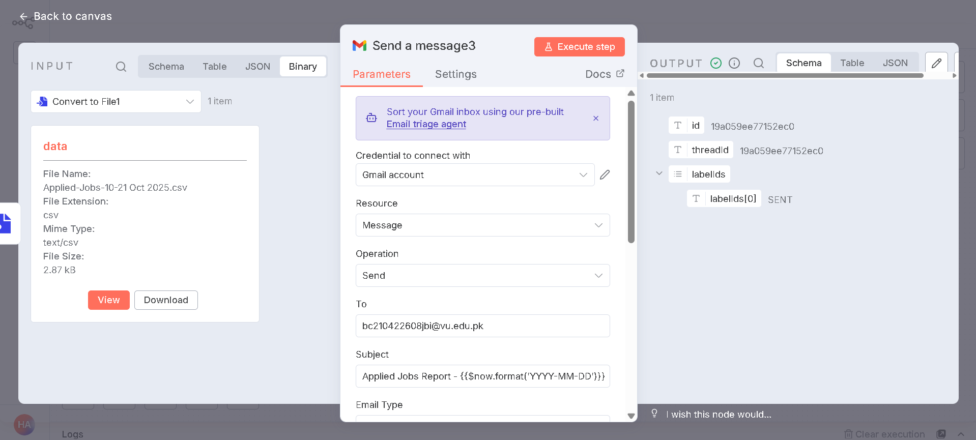

Scheduling & Automation
The entire workflow is scheduled to run every 24 hours, ensuring it fetches and applies to all new job listings uploaded within the past 24 hours — entirely hands-free.
